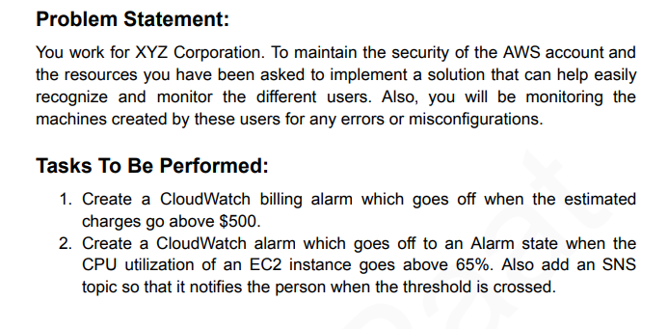

Set Up:  
  
A **CloudWatch Billing Alarm** → triggers when AWS bill > $500

A **CPU Utilization Alarm** → triggers when EC2 CPU > 65%  
 → both send notifications via **SNS topic**

## **🪜 STEP 1 — Create an SNS Topic (for notifications)**

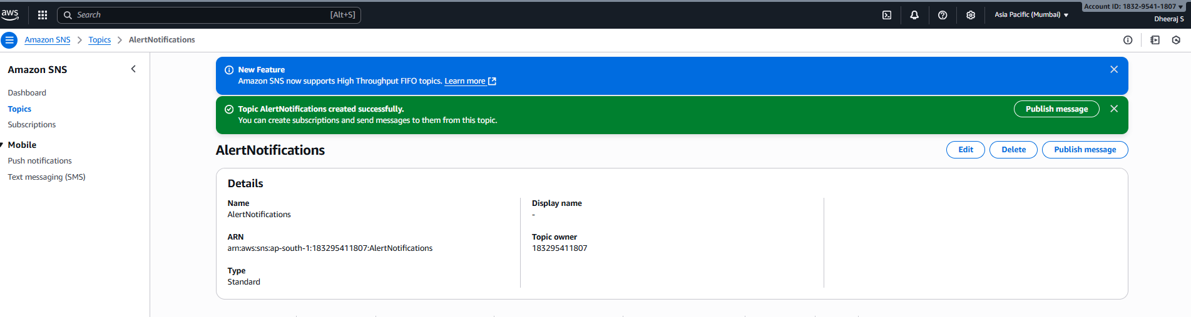

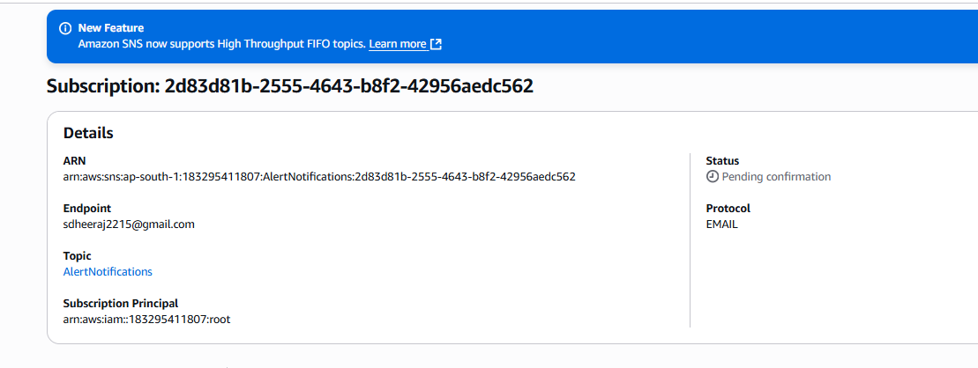

## **🪜 STEP 2 — Create Billing Alarm (for > $500)**

⚠️ **Important:** Billing alarms work **only in the us-east-1 (N. Virginia)** region, regardless of where you use AWS.

### **Enable Billing Metrics (only once)**

1. Go to **AWS Console → Billing → Billing preferences**
2. Under **“Receive Billing Alerts”** → ✅ **check the box**
3. Click **Save preferences**

Wait **5–10 minutes** for metrics to start appearing in CloudWatch.

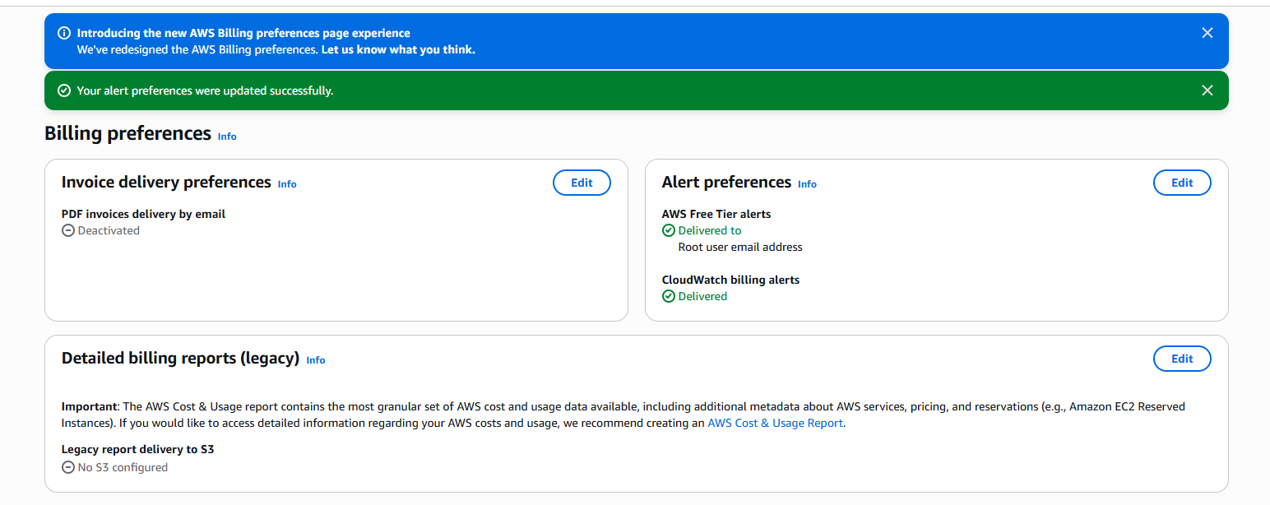

### **Create Billing Alarm**

1. Go to **CloudWatch → Alarms → All alarms → Create alarm**
2. Click **Select metric**
3. Navigate:  
    Billing → Total Estimated Charge → USD
4. Select the metric and click **Select metric**
5. In conditions:  
   * Whenever metric is **Greater than** 500
   * Period: 6 hours
6. Click **Next**
7. Under **Notification**, select:  
   * Send notification to existing topic: AlertNotifications
8. Click **Next**
9. Name the alarm: BillingAlarmOver500USD
10. Click **Create alarm**

✅ You’ll now see an alarm for billing that changes to **ALARM** if charges exceed $500.

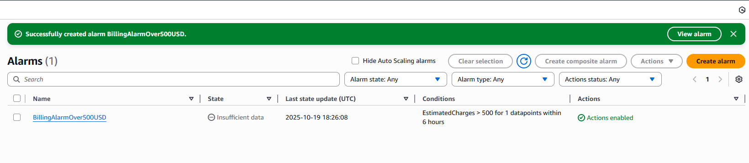

## **🪜 STEP 3 — Create EC2 CPU Utilization Alarm (>65%)**

1. Go to **CloudWatch → Alarms → Create alarm**
2. Click **Select metric**
3. Browse:  
    EC2 → Per-Instance Metrics → CPUUtilization
4. Select your instance (check InstanceId)  
    → Click **Select metric**
5. Set:  
   * Whenever CPUUtilization is **Greater than 65**
   * For **2 consecutive periods** of **5 minutes**
6. Click **Next**
7. Under **Notification**, choose **existing SNS topic → AlertNotifications**
8. Click **Next**
9. Name it: HighCPUUtilizationAlarm
10. Click **Create alarm**

✅ This alarm will trigger and send an email when CPU goes above 65%

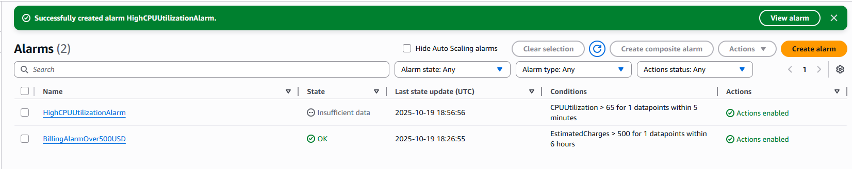

## **🧾 STEP 4 — Test and Verify**

* **Billing Alarm:** You can’t force it, but you can view its metric graph.
* **CPU Alarm:** To test → SSH into EC2 and run a CPU stress command:  
    
  sudo amazon-linux-extras install epel -y  
  sudo yum install stress -y  
  stress --cpu 2 --timeout 120
* Wait 2–5 minutes → you’ll see **Alarm state: ALARM** and an email alert.

